# 启动

Filebeat Modules enable you to quickly collect, parse, and index popular log types and view pre-built Kibana dashboards within minutes

[Metricbeat Modules](https://www.elastic.co/guide/en/beats/metricbeat/6.0/metricbeat-modules.html)provide a similar experience, but with metrics data. In this context, Beats will ship data directly to Elasticsearch where [Ingest Nodes](https://www.elastic.co/guide/en/elasticsearch/reference/6.0/ingest.html) will process and index your data.

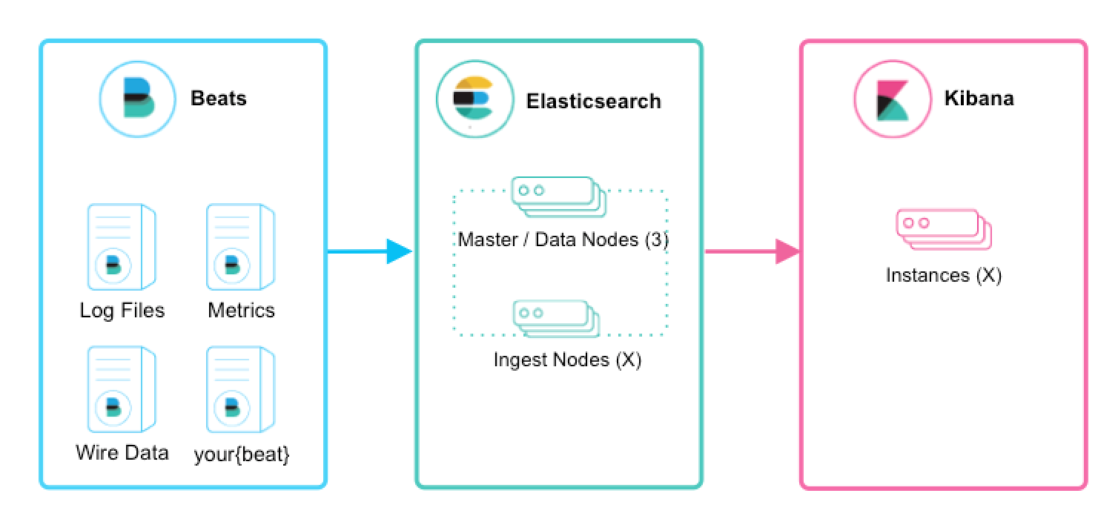

# 扩展提取

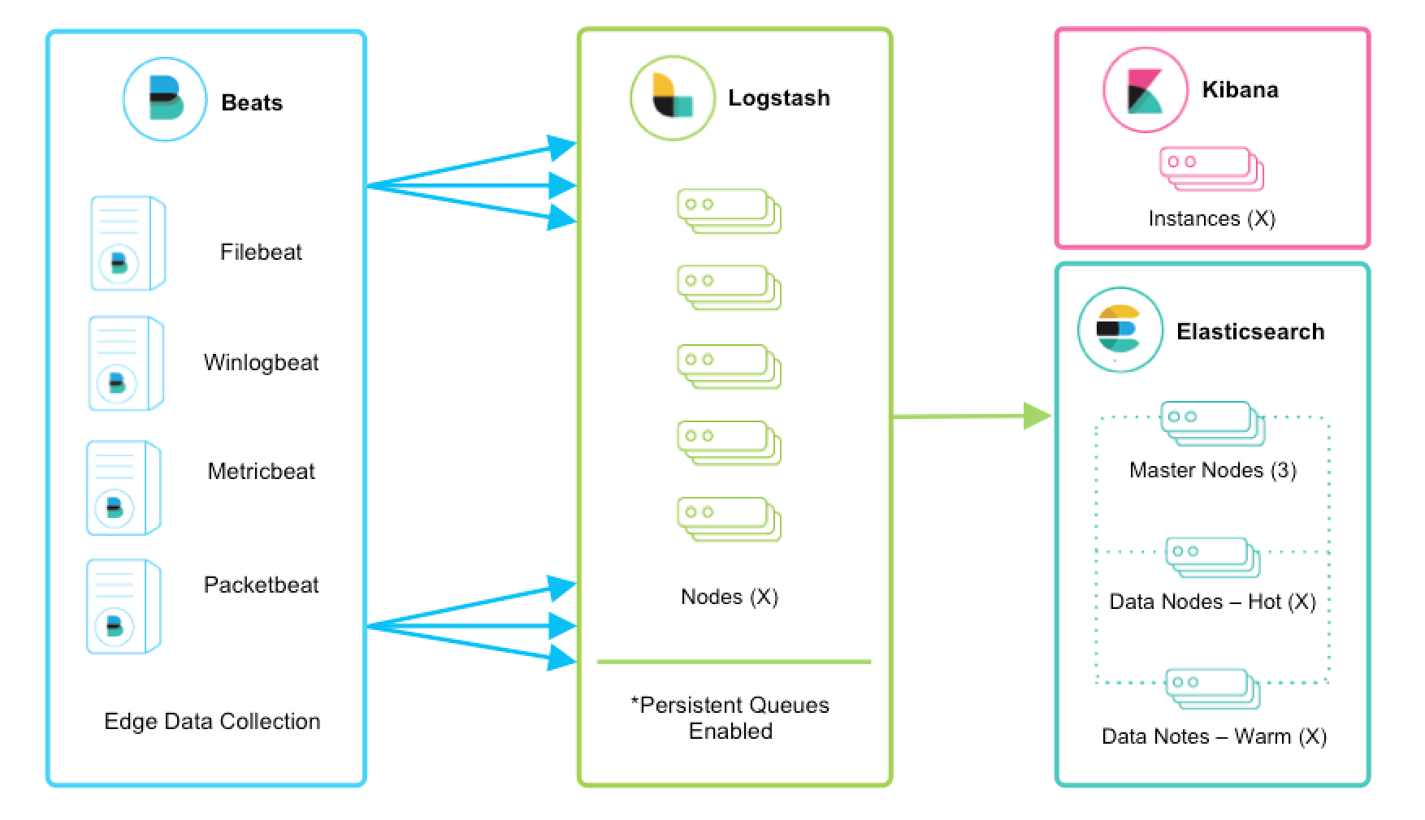

1. Beats run across thousands of edge host servers, collecting, tailing, and shipping logs to Logstash
2. Logstash serves as the centralized streaming engine for data unification and enrichment
3. The [Beats input plugin](https://www.elastic.co/guide/en/logstash/current/plugins-inputs-beats.html) exposes a secure, acknowledgement-based endpoint for Beats to send data to Logstash.

## 2.1 logstash的扩展性

Logstash is horizontally scalable and can form groups of nodes running the same pipeline.

* A minimum of two Logstash nodes are recommended for high availability.
* It’s common to deploy just one Beats input per Logstash node, but multiple Beats inputs can also be deployed per Logstash node to expose independent endpoints for different data sources.

# 三.添加其他源

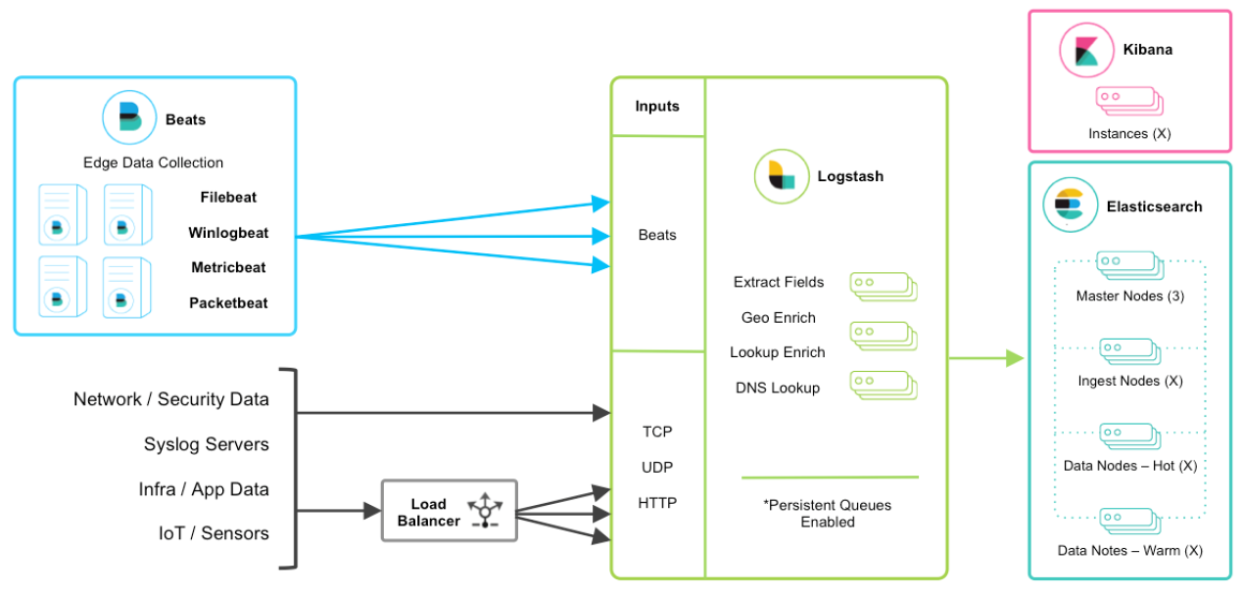

# 四. Integrating with Messaging Queues

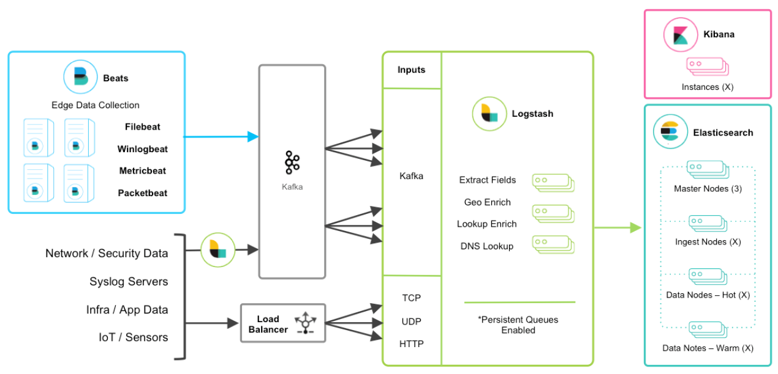

Kafka can serve as a data hub where Beats can persist to and Logstash nodes can consume from.

The other TCP, UDP, and HTTP sources can persist to Kafka with Logstash as a conduit to achieve high availability in lieu of a load balancer. A group of Logstash nodes can then consume from topics with the [Kafka input](https://www.elastic.co/guide/en/logstash/current/plugins-inputs-kafka.html) to further transform and enrich the data in transit.